Machine Description | This machine hosts a Drupal website on a LAMP stack and is vulnerable to Drupalgeddon2 (CVE-2018-7600). An attacker can send crafted HTTP requests to execute arbitrary PHP code compromise the web application and potentially gain control of the underlying server. Remediation requires patching Drupal removing suspicious files rotating credentials and checking logs for signs of exploitation.
Target IP | 10.184.103.114
Vulnerability Name | Drupalgeddon2 — remote unauthenticated remote code execution in Drupal
Port and Service | TCP 80/ http Apache 2.2.22 (Drupal CMS )
Severity and Score | 9.8 Critical
Attack Vector | CVSS:3.0/AV:N/AC:L/PR:N/UI:N/S:U/C:H/I:H/A:H
Proof Of Concept | STEP 1 : Discover the target IP address  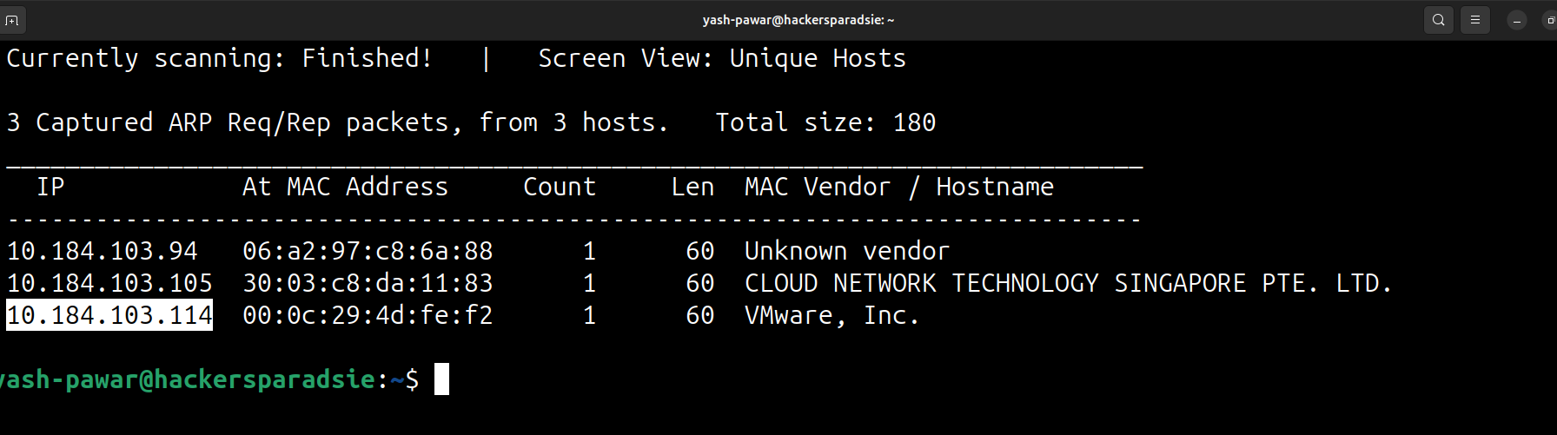  STEP 2 : Scan for open ports using Nmap  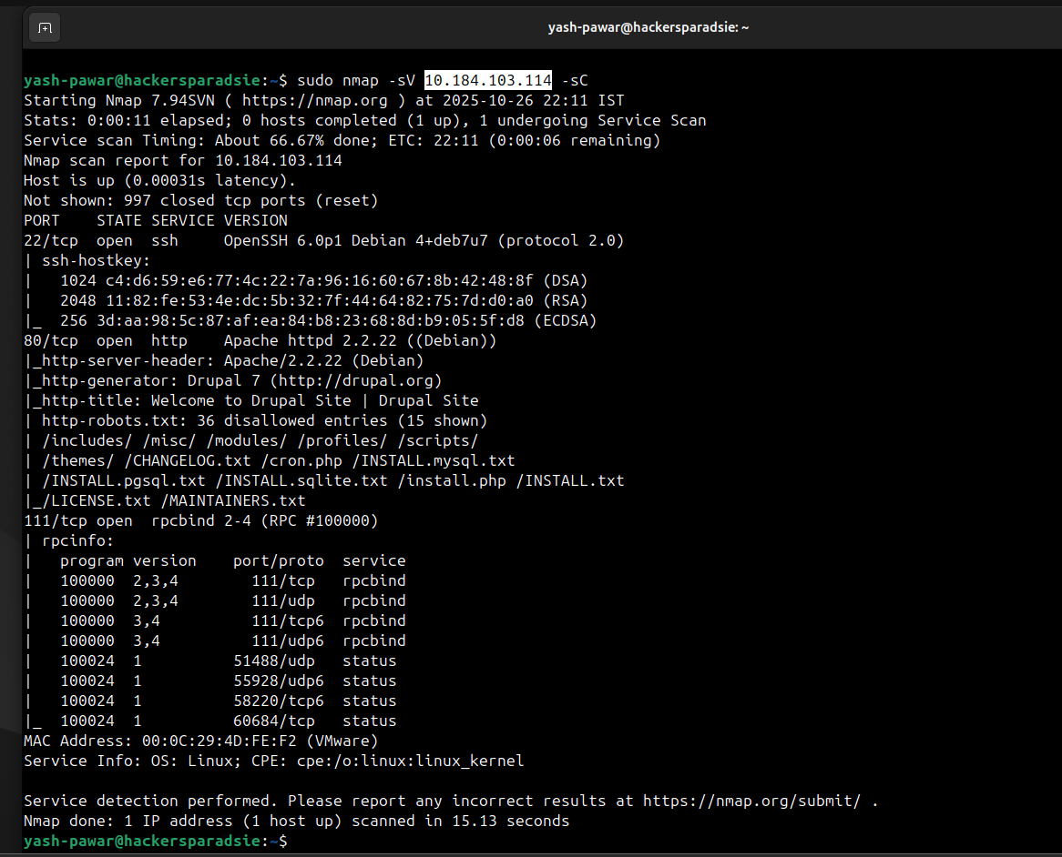  Here we can see that site is running CMS of Drupal on 80  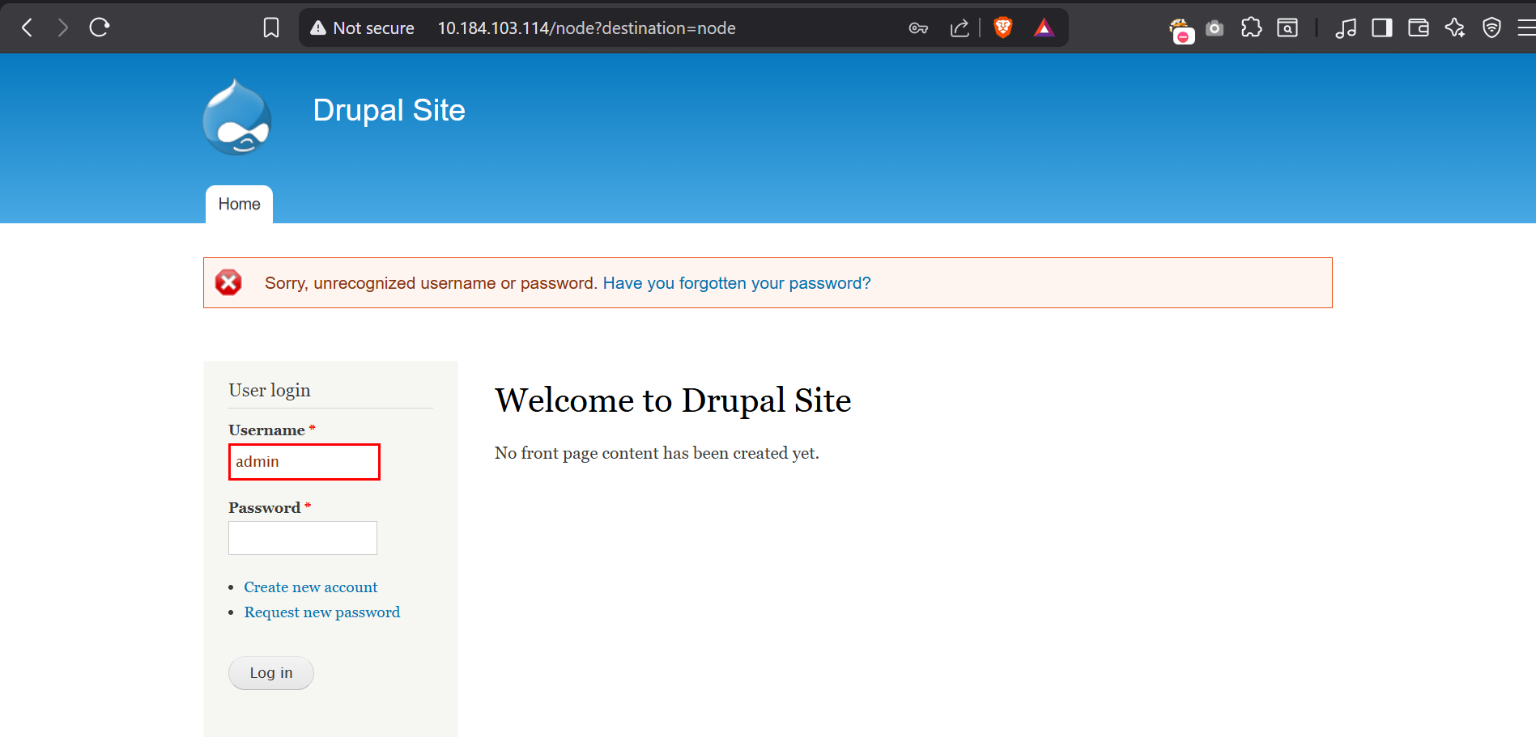  Lets find If we can find any exploit related to it on Searchsploit  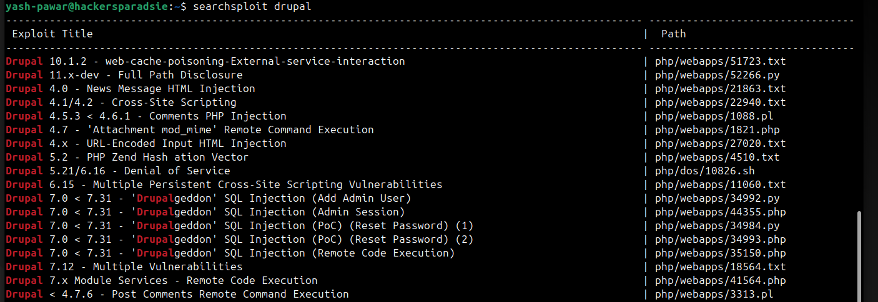  STEP 3 : So there are some exploits so lets use Metasploit.  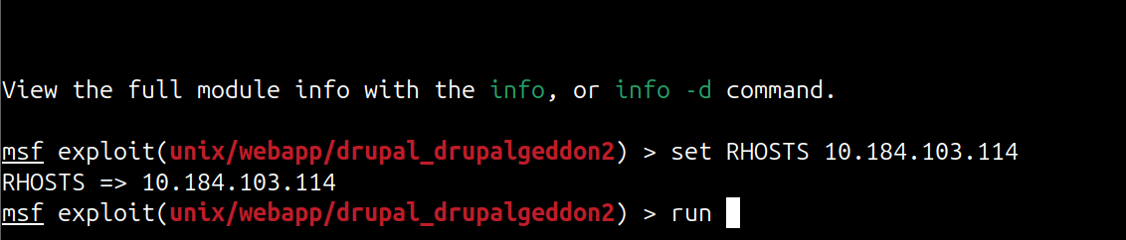  We got access ass www-data user  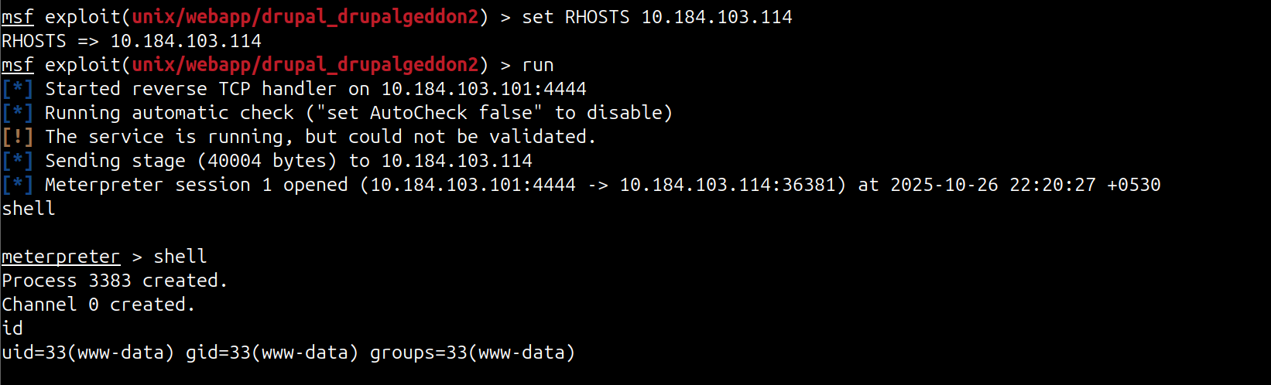  STEP 4 : Lets try to escalate privileges  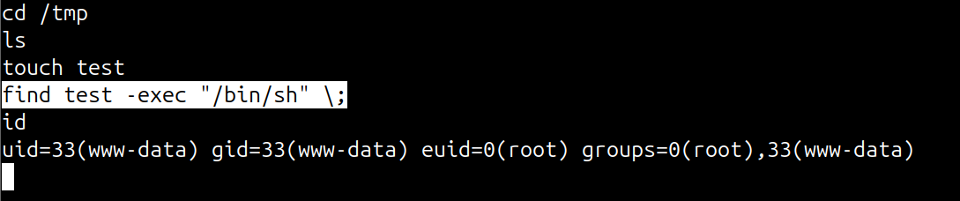  Here we can see we got the root  Username : flag4  Password : orange
Impact | - full site takeover attacker can run arbitrary PHP code and control site content and modules  - remote command execution attacker can execute system commands leading to server compromise  - data breach sensitive site data user records and configuration can be exfiltrated  - credential theft attacker can harvest admin credentials and session tokens for further access
Remediations | - update Drupal core to patched version  - remove suspicious modules or files  - reset admin and database credentials  - review logs for exploitation signs  - restrict file permissions and disable PHP in uploads  - enable WAF or security modules
Reference | https://unit42.paloaltonetworks.com/unit42-exploit-wild-drupalgeddon2-analysis-cve-2018-7600/

